**SQL ASSESMENT**

**PROBLEM 1** – Create a table consisting of employee id, name, department, salary and find the 3rd highest salary.

**SOLUTION:**

Step 1: I created a database of EMPLOYEE in which I created a table of desired columns with its respective data types.

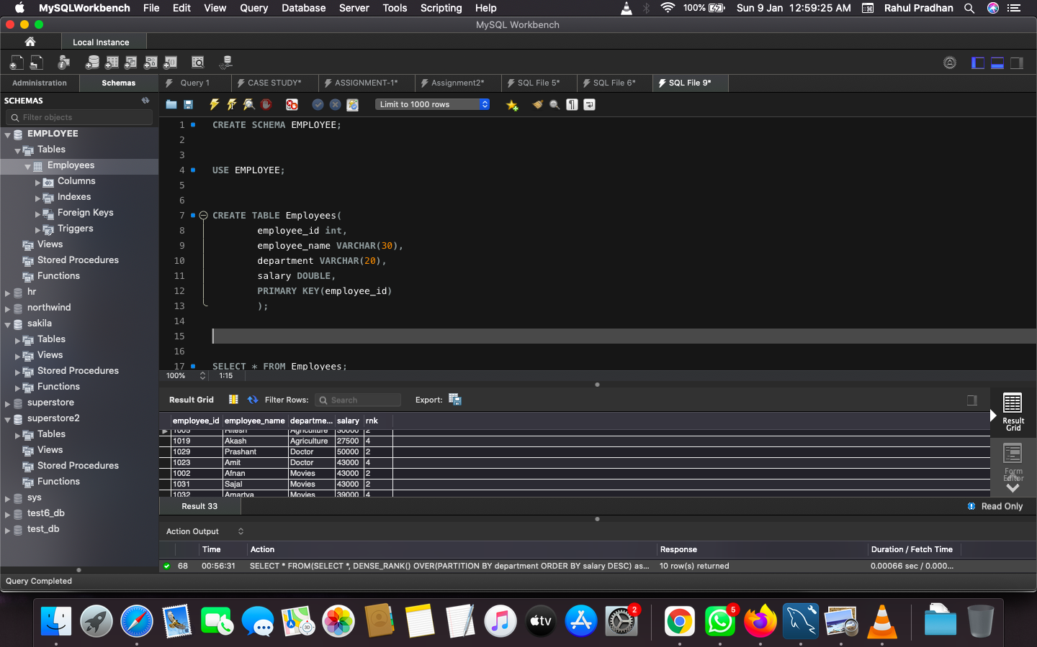

Step 2: Inserted values as per the table requirement and took at least 3 similar salaries

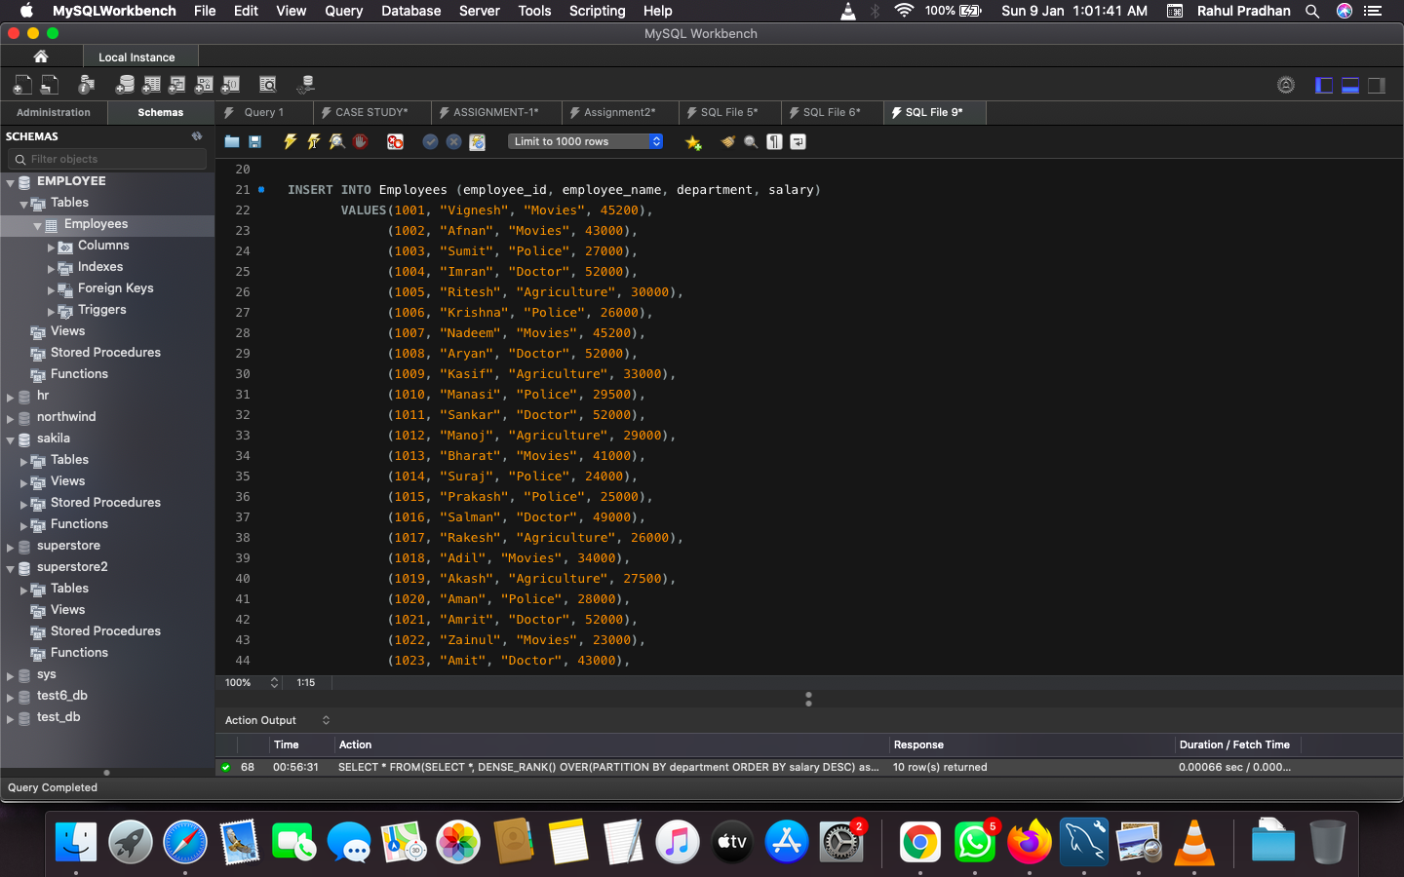

Step 3: Ran the above table to check everything is in table is set.

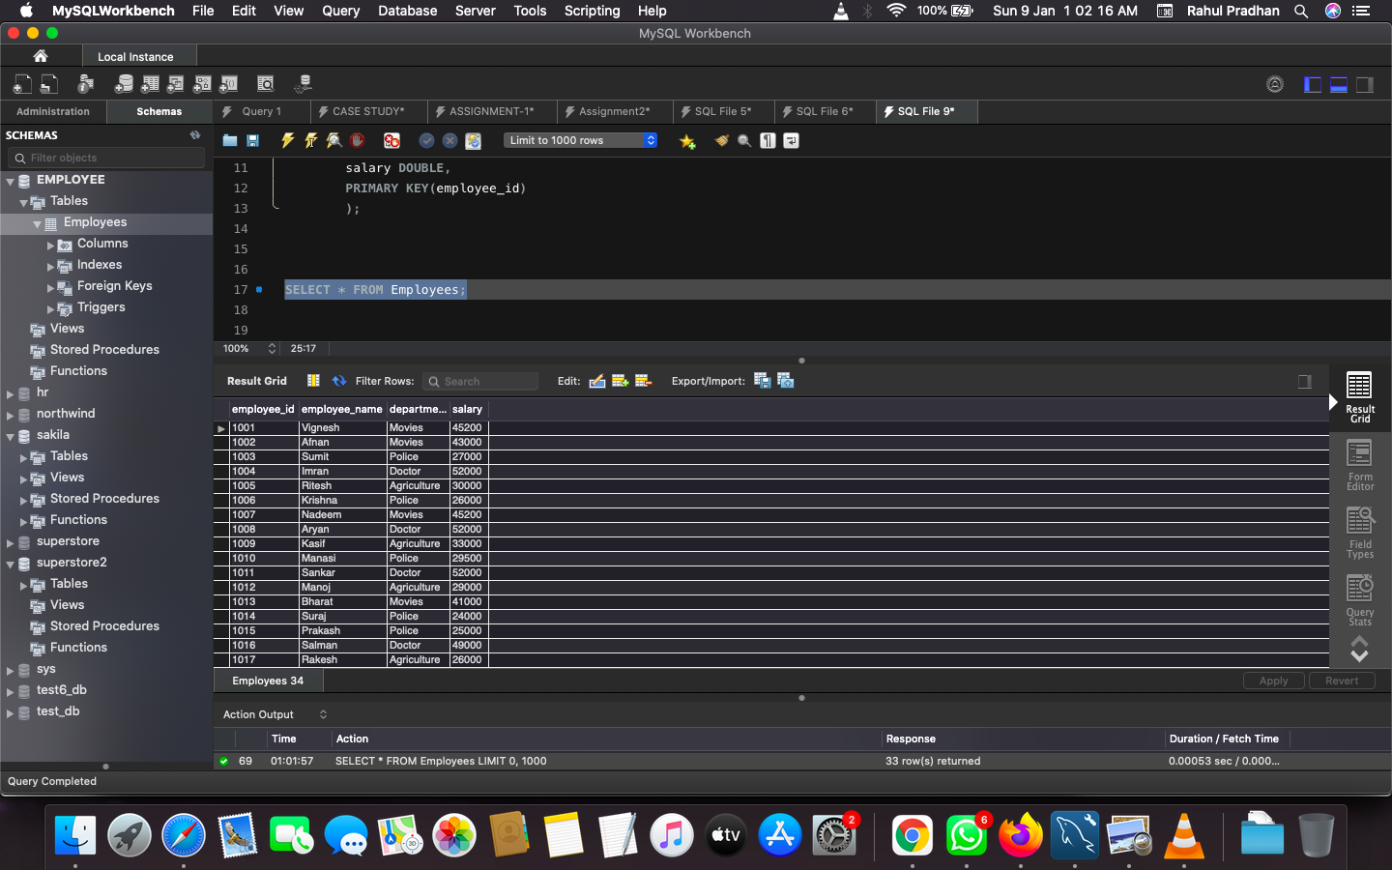

Step 4: Used Dense_Rank() function to list the salary in descending order and gave it an alias rnk, Then selected all the columns in the sub query and written a WHERE clause to fetch gather only the 3rd highest salary index.

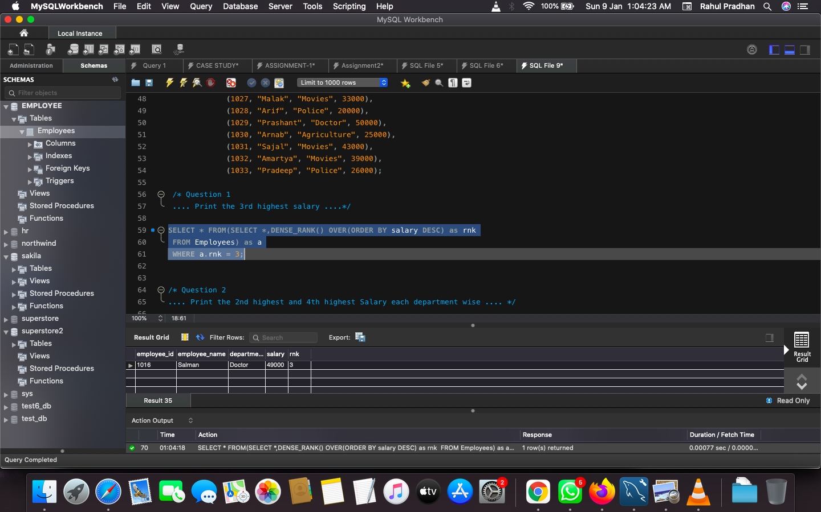

**PROBLEM 2** – Get 2nd and 4th highest salary from each department

**SOLUTION:**

Repeated the above procedure along with Partition by clause for department in Dense_Rank() function and written a WHERE clause to fetch 2nd highest or 4th highest salary from each department.

